Electrochemical Cells
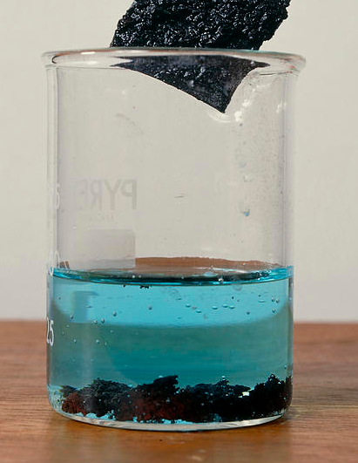

Redox reactions as electron transfer
-When zinc metal is added to copper sulfate solution, zinc atoms displace copper ions from solution according to the equation:

Zn_{(s)} + Cu²⁺_{(aq)} Zn²⁺_{(aq)} + Cu_{(s)}

-This reaction is comprised of two half-reactions:

oxidation: Zn_{(s)} Zn²⁺_{(aq)} + 2e⁻
reduction: Cu²⁺_{(aq)} + 2e⁻ Cu_{(s)}

-Looking at the two half-reactions, it can be seen that each zinc atom transfers two electrons to a copper ion

-This transfer happens at the surface of the zinc metal

-It is possible to physically separate the oxidation and reduction half-reactions in a redox equation, as long as they are connected by a wire to allow the electrons released during oxidation to flow to the location where reduction is taking place

-The electrons flow through the wire as an electrical current, which can be used to perform work

-Electrochemical (galvanic) cells turn chemical potential energy into electrical energy, when a spontaneously occurring redox reaction (eg with E° > 0) is used to drive an electrical current
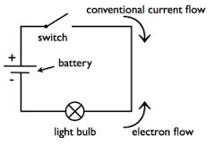
Electrical current and voltage
-In an electric circuit, electrons flow from the negative terminal, through an appliance and back to the positive terminal

-As they do this, they carry the energy needed to operate the device

-An electric current is defined as the flow of charge (either electrons or ions)

-The unit of charge is the Coulomb. 1 Coulomb (C) is defined as the amount of charge carried by 6.25 x 10¹⁸ electrons.

-For a current to flow, the charged particles must be provided with energy. This energy can be transferred from the electrons to another device.

-The unit of energy is the Joule (the energy required to apply a force of 1 N over a distance of 1m)

-Rather than measure Joules, for electrical energy, we measure the number of Joules carried by each coulomb of charge. This unit of electrical energy, the volt (V) is defined as 1 joule per coulomb)

Structure of Electrochemical (Galvanic) Cells
-The Daniell Cell below uses the same Zn/Cu²⁺ reaction as shown previously
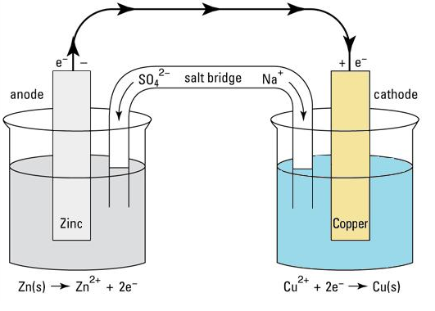
-The parts of a cell where oxidation and reduction occur are called the anode and the cathode respectively.

-This can be remembered by the menomonic: AN OIL RIG CAT
(at the ANode, Oxidation Is Loss. Reduction Is Gain at the CAThode)

Components of an Electrochemical Cell (with the Daniell Cell as an example)

Anode
-The electrode where oxidation takes place.

-In a galvanic cell (battery), this is labelled as the negative electrode as electrons are released here.

-Can be involved in the reaction (as in the Daniell cell), or can be inert (typically graphite or platinum).

-In a Daniell Cell, a zinc anode is immersed in zinc sulfate electrolyte solution. As the oxidation half-reaction occurs, the Zn²⁺ ions that are formed move into the electrolyte and the electrons released move through the wire.

Wire/External Circuit
-For the reaction to take place, the electrons produced at the anode need a path to move to the cathode, so that they can be used up during reduction.

-In addition to a simple wire, the circuit may contain other components, so that the electrical energy of the electrons can be used to perform work.

Cathode
-At the cathode, the electrons produced at the anode are used in the reduction half-reaction.

-In a galvanic cell, the cathode is the positive electrode.

-As with the anode, the cathode may be reactive or inert.

-In a Daniell Cell, the cathode is a copper electrode immersed in copper sulfate electrolyte solution. The electrons are accepted by Cu²⁺ ions, which are reduced into copper atoms on the surface of the copper cathode.

Electrolyte solutions & salt bridge
-Both electrodes need to be immersed in electrolyte solution.

-The presence of electrolytes allows charge to flow in the solution and some of the electrolytes present are used in the oxidation and reduction half-reactions.

-The two electrolyte solutions are connected by a salt bridge, which contains a highly concentrated electrolyte solution comprising an electrolyte that is unable to react with any other components of the cell.

-The electrolyte solutions and salt bridge allow the completion of the circuit.

-Without these features, positive charge would build up at the anode as electrons are lost and negative charge would build up at the cathode as electrons are gained, eventually preventing the flow of electrons through the external circuit.

- The salt bridge allows negative charge to flow from the cathode, back to the anode completing the circuit.

-In the circuit, charge flows as electrons in the external circuit and as ions in the electrolyte/salt bridge.

EMF & Standard Reduction Potential

Electromotive force (emf)

-In a cell, such as the one above, electrons are “pushed” through the external circuit by the reductant (Zn) and “pulled” through by the oxidant

-As different substances have different strengths as oxidants and reductants, different cells will exert a different degree of force on the electrons in the circuit

-The force results from the difference in the electrical potentials of the two half-cells

-This force is known as the electromotive force (emf), cell voltage or potential difference

-The emf of a cell is given the symbol E_{cell} and it is measured in volts (V)

-The magnitude of the emf of a cell depends on the nature of the oxidants and reductants, the concentration of the electrolytes, the pressure of gases in the cell and the temperature

-Because of this cell potentials are often measured under standard conditions of 1 molL⁻¹ concentration of dissolved substances, gas pressures of 100.0 kPa and temperatures of 298 K (25°C)

-When measured under these conditions, the emf is referred to as the standard cell potential and is given the symbol E°_{cell}

Calculating Cell Potential using Standard Reduction Potentials
-The electrical potential of a cell is equal to the sum of the electrical potentials of the two half-cells

-It is impossible to directly measure the electrical potential (reduction potential) of a half-cell on its own, as all electrical cells are a combination of two half-cells

-To overcome this, the hydrogen half-cell is used as a reference and is designated an electrical potential of 0.0 V under standard conditions

2H⁺_{(aq)} + 2e⁻ H_{2(g)} E° = 0 V

-The E° values for half-cells are determined by measuring the voltage produced in a cell containing the half-cell of interest and a hydrogen half-cell

-The E° values for various reduction half-equations (eg the half-reactions that occur at the cathode) are listed on your data sheet (Standard Reduction Potentials)

-To calculate the E° value for an oxidation half-reaction, simply reverse the sign for the reduction half-reaction that represents its reverse reaction)

eg to calculate the E° value for the oxidation of copper to the copper (II) ion, use the data sheet to find the E° value for the reduction of copper (II) ions:

Cu²⁺ + 2e⁻ Cu E° = 0.34 V

So the reverse reaction will have an E° value of – 0.34 V

-As the anode reaction (where the reductant is oxidised) is always an oxidation reaction, the sign of its E° value will always be reversed when calculating cell potential

-As such, standard cell potential can be calculated using the formula
E°_{cell} = E°_{oxidant} - E°_{reductant}

Example: Calculate the cell potential of a Daniell cell under standard conditions

Method 1
In a Daniell cell zinc is oxidised and copper ions are reduced
Oxidation: Zn_{(s)} Zn²⁺_{(aq)} + 2e⁻ E°= +0.76 V (as reverse reaction has E° = -0.76 V)
Reduction: Cu²⁺_{(aq)} + 2e⁻ Cu_{(s)} E° = 0.34 V

E°_{cell} = E°_{oxidation} + E°_{reduction}
= 0.76 + 0.34
= 1.10 V

Method 2
In a Daniell cell zinc is oxidised and copper ions are reduced, therefore zinc is the reductant and copper is the oxidant

The E° values for the substances present are:
Zn²⁺_{(aq)} + 2e⁻ Zn_{(s)} E° = -0.76 V
Cu²⁺_{(aq)} + 2e⁻ Cu_{(s)} E° = 0.34 V

E°_{cell} = E°_{oxidant} - E°_{reductant}
= 0.34 – (- 0.76)
= 1.10 V

Predicting Reaction Tendency

Predicting reaction tendency by E°_{cell} values
-As well as determining cell potential, the list of standard reduction potentials can be used to determine if a redox reaction will occur spontaneously

-This is because only redox reactions with an E°_{cell} > 0 will occur spontaneously

-The higher the E° value for a reaction, the larger the equilibrium constant (K)

Questions: Use the list of standard reduction potentials to write redox equations for the following reactions and determine the E° value and whether they will occur spontaneously
- Solid nickel is added to a solution of zinc chloride
- Chlorine gas is bubbled through a solution of iron (II) nitrate
- Acidified potassium permanganate is used to oxidise oxalic acid (H₂C₂O₄)

Predicting reaction tendency by oxidant/reductant strength
-The tendency of redox reactions to take place depends on the relative strengths of the reactants as reductants and oxidants

-For a reaction to take place, the reactants must have a greater tendency to reduce/oxidise one another than the products do

eg Calcium metal cannot displace K⁺ ions from solution. This is because potassium metal is a stronger reductant (is more reactive) than calcium metal, so the reverse reaction would be more likely to proceed than the forward reaction.

-To predict if a reaction will occur, we can consider if the reduction half-reaction is more likely to occur than the reverse of the oxidation half-reaction

-Oxidant reductant strength can be determined using the list of standard reduction potentials

-The strongest oxidants are at the top left of the table and the weakest oxidants are at the bottom left

-The strongest reductants are at the bottom right of the table and the weakest reductants are at the top right

-Reactions will tend to occur if the oxidant is listed higher in the table than the reductant (eg if the oxidant is a stronger oxidant than the species produced when the reductant becomes oxidised)
-This is because ant reaction with the oxidant listed lower than the reductant will hace a negative E° value

Top left/bottom right rule: A redox reaction will only occur spontaneously if the reactants are fount to the top-left and bottom-right of one another in the list of Standard Reduciton Potentials.

eg Br_{2(l)} can oxidise any substance listed below Br⁻_{(aq)} on the right of the table, but cannot oxidise substances above it, so Br_{2(l)} could be used to oxidise Pb_{(s)} into Pb²⁺_{(aq)}, but not Cl⁻_{(aq)} into Cl_{2(g)}
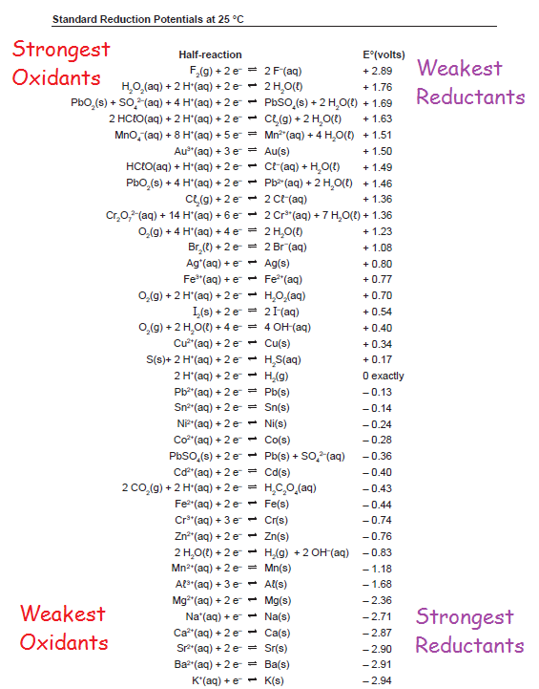

Practice Question: Use the list of standard reduction potentials to determine which of the following metals are able to displace Co²⁺ ions from solution- cadmium, aluminium, gold, chromium, silver, barium, manganese, copper.

Uses of Standard Reduction Potentials
-As shown above, standard reduction potentials call be used to calculate cell potential under standard conditions

-They can also be used to predict reaction tendency, as reactions with a positive E° value will tend to have a large equilibrium constant and thus tend to occur spontaneously (even if their rate is very slow)

-Standard reduction potentials can also be used to predict and explain:

-Metal displacement reactions
-Halogen displacement reactions
-Reaction of metals with water (2H₂O_{(l)} + 2e⁻ H_{2(g)} + 2OH⁻_{(aq)} E°= -0.83 V)
-Reactions of metals with dilute acids (2H⁺_{(aq)} + 2e⁻ H_{2(g)} E°= 0 V)
-Reactions of metals with concentrated nitric acid
(metals with E° < 0.95 V will react to produce NO, which is immediately oxidised to NO₂. Note the half reaction for the reduction of nitrate ions does not have an E° value as it only occurs when the concentration is significantly greater than 1 molL⁻¹)

-They can also be used to explain why many substances will only react in acidified solution (eg MnO₄⁻ and Cr₂O₇²⁻ both have H⁺ as a reactant in their half-equations)

Limitations in the use of Standard Reduction Potentials
-The weakly oxidant metal ions (Group 1 and 2 metal ions and Al³⁺) will not participate in redox reactions in aqueous solution, regardless of the overall E° value for the reaction. As such, they can be ignored when predicting reactions in aqueous solution.

-Nitrate and sulfate ions will only participate in redox reactions when present in concentrated nitric or sulfuric acids (eg E° values don’t apply as the concentration is greater than 1 molL⁻¹)

Concentrated Nitric acid: NO₃⁻_{(aq)} + 2H⁺_{(aq)} + e⁻_{(aq)} NO_{2(g)} + H₂O_{(l)}
Less concentrated nitric acid (4-6 molL⁻¹): NO₃⁻_{(aq)} + 4H⁺_{(aq)} + 3e⁻_{(aq)} NO_{(g)} + 2H₂O_{(l)}
Concentrated sulfuric acid: SO₄²⁻_{(aq)} + 4H⁺_{(aq)} + 2e⁻ SO_{2(g)} + 2H₂O_{(l)}

-Water can act as a reductant or an oxidant to different degrees depending on the conditions present. Reactions involving H⁺ or OH⁻ ions and water have their E° values calculated under standard conditions (all concentrations at 1.0 molL⁻¹), which means that they do not apply to neutral solution where [H⁺] = [OH⁻] = 1.0 x 10⁻⁷molL⁻¹

-At neutral pH, the main half-reactions that occur are:
2H₂O_{(l)} O_{2(g)} + 4H⁺_{(aq)} + 4e⁻ E = -0.82 V
2H₂O_{(l)} + 2e⁻ H_{2(g)} + 2OH⁻_{(aq)} E = -0.41V
Commercial Cells


-While the Daniell cell shown below is useful as a model galvanic cell, many of its features make cells like this unsuitable for real world applications

-These issues include:
-The anode is consumed in the anode reaction
-The liquid electrolyte is prone to spillage
-The voltage generated is relatively low
-The total amount of electrical energy able to be delivered before the battery is discharged is relatively low

-Commercially available galvanic cells contain a number of specialised design features to make them better suited for the role they perform

-This is illustrated by the cells below
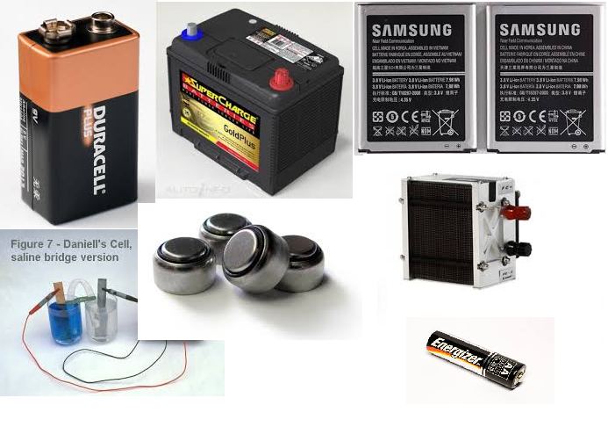
-Depending on their use, batteries may be constructed differently in order to:

-Maximise the energy stored (depends on battery chemistry)

-Allow recharging (many cells can be recharged by applying a current to the battery to drive the reverse reaction)

-Alter the voltage produced (dependant on battery chemistry and the number of cells within the battery)

-Allow the use of liquid/gaseous fuels which are continually added to the cell

-Allow their use in applications involving rapid and/or vigorous movement (use of an electrolyte paste in dry cells, sealed batteries etc)
-The cells are also classified based on the type of reactants and the reversibility of the reaction:

-Primary cells: non-rechargeable, redox reaction only occurs in forward direction

-Secondary cells: rechargeable. Reverse reaction occurs when a voltage greater than the cell voltage is applied to the cell

-Fuel cells: reactants are constantly supplied to electrodes and products are constantly removed

-While the outward appearance of these cells varies considerably, all cells contain the following features:

-Electrodes: Site of the oxidation (anode) and reduction (cathode) half-reactions. Electrodes may be reactive or inert and can be constructed in a variety of ways, including using nanoparticles

-Electrolyte: Allows charge to flow as ions (+ moves towards cathode, - moves towards anode), completing the circuit. Depending on the cell structure, a salt bridge may be present. The electrolyte can be a liquid, a paste or a solid polymer

-Reactants for the oxidation and reduction half-reactions. Depending on the cell type these may be present as the electrodes themselves, as part of the electrolyte or may be continuously added (in fuel cells)

-External circuit: Regardless of the cell type, cells must be connected to an external circuit allowing electrons to move from the anode to the cathode, in order for the redox reaction to proceed

-The following Commercial cells are covered in the Year 12 Chemistry course:

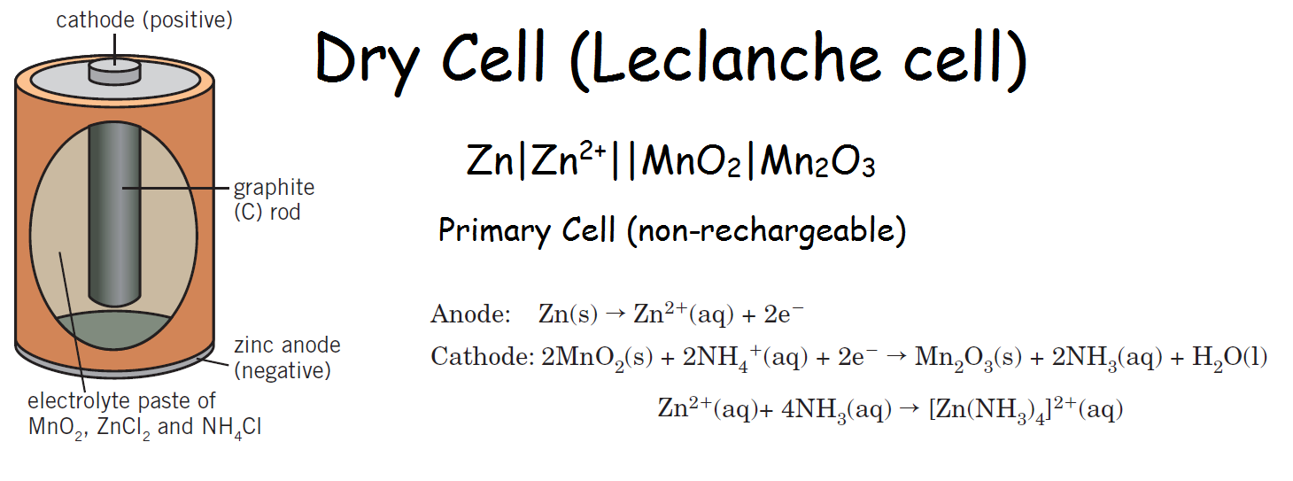

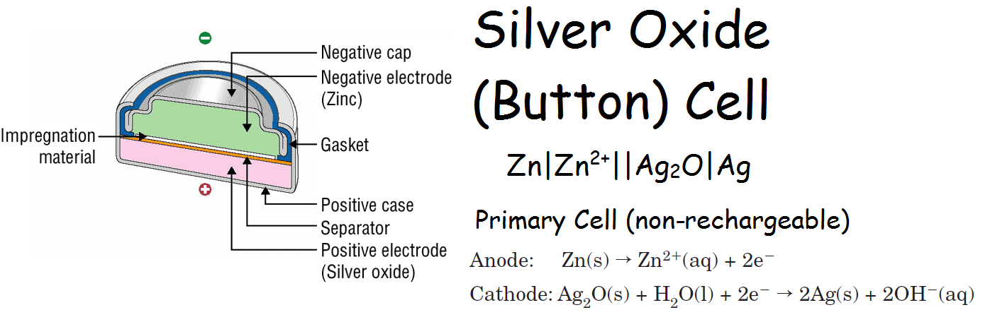

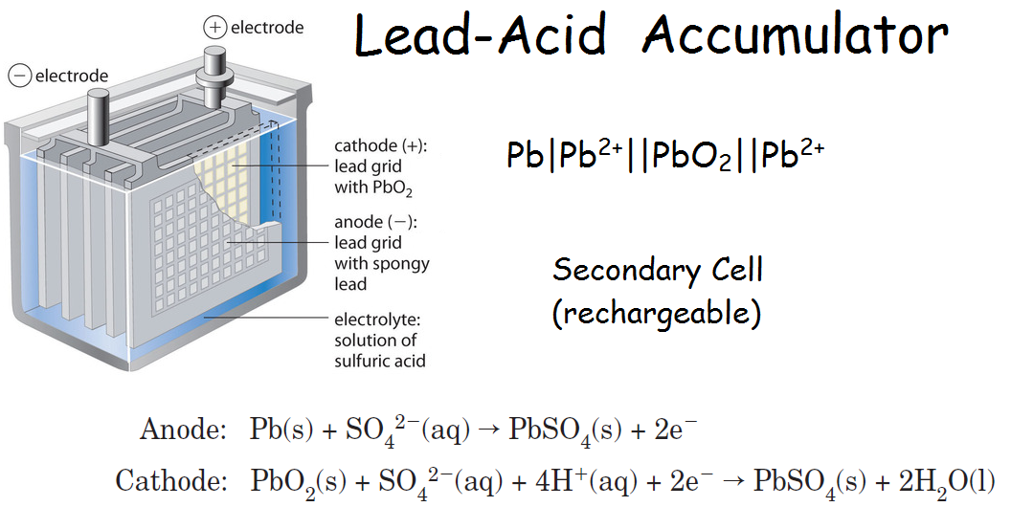

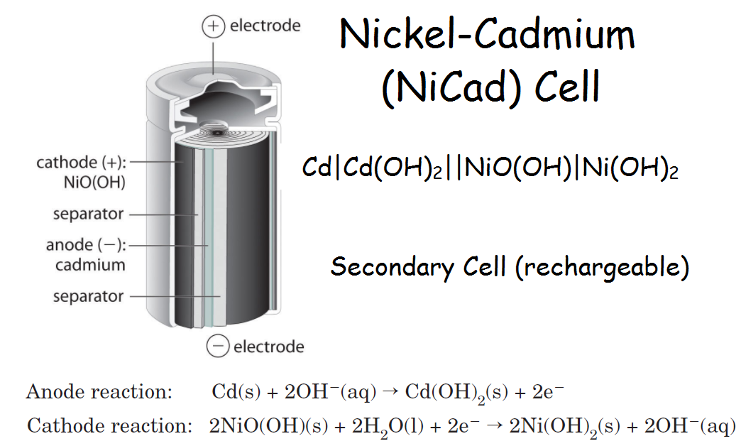

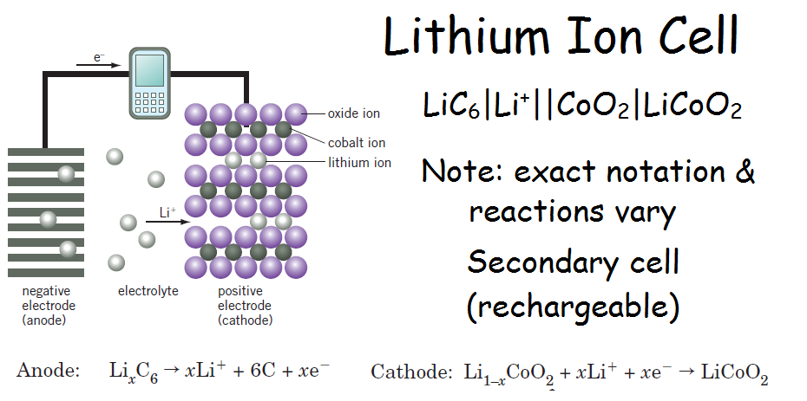

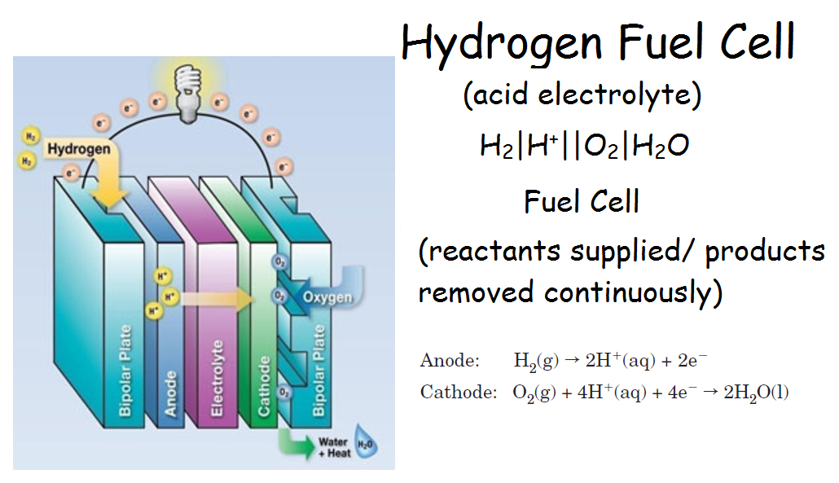

Corrosion

-Almost all metals will react with oxygen in redox reactions

-Metals that are the strongest reductants (those found towards the bottom right of the SRP table) will react most vigorously

-Various methods of corrosion prevention are used to protect metallic structures

Dry Corrosion
-Many reactive metals will react with oxygen in the absence of water according to the general equation:
xM_{(s)} + ^{y}/₂ O_{2(g)} M_{x}O_{y(s)} eg 2Mg_{(s)} + O_{2(g)} 2MgO_{(s)}

-The reaction occurs at the surface of the metal, resulting in a thin layer of metal oxide covering the metal

-For many metals, the oxide covering is impervious to air, thus preventing additional corrosion

-When iron rusts, the iron oxide layer is porous, permitting further corrosion

-This corrosion must be prevented, as it significantly weakens the material

Wet Corrosion/Rusting of Iron
-Many metals (such as iron) require both water and oxygen to be present for corrosion to occur (hence ‘wet corrosion’)

-Wet corrosion is considered an electrochemical process, as the oxidation and reduction take place at different locations on the metal

-The iron acts as the anode: Fe_{(s)} Fe²⁺_{(aq)} + + 2e⁻

-The cathode reaction occurs at an impurity in the iron (eg carbon) or in an area of high oxygen concentration:
O_{2(g)} + 2H₂O_{(l)} + 4e⁻ 4OH⁻_{(aq)}

-The image below highlights the electrochemical nature of wet corrosion, by showing the similarities between corrosion occurring on the surface of a piece of iron and an electrochemical cell using the oxidation of iron at the anode

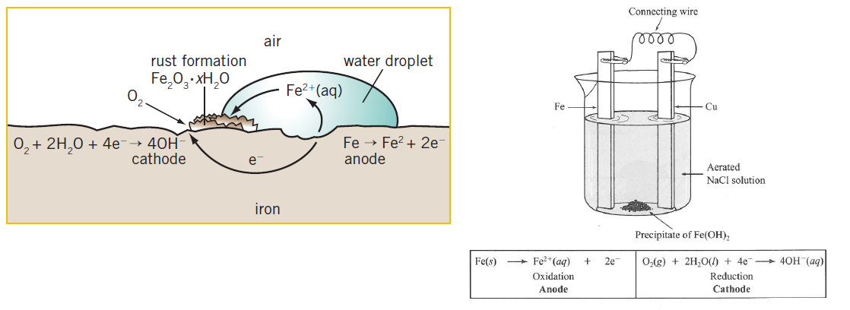
-The Fe²⁺ and OH⁻ ions react in a series of further reactions to produce rust (hydrated iron oxide, Fe₂O₃.xH₂O):
Fe²⁺_{(aq)} + 2OH⁻_{(aq)} Fe(OH)_{2(s)}
Fe(OH)_{2(s)} + OH⁻_{(aq)} Fe(OH)_{3(s)} + e⁻

-The Fe(OH)_{3(s)} is partially dehydrated to form rust (Fe₂O₃.xH₂O), giving an overall equation:
4Fe_{(s)} + 3O_{2(g)} + 2xH₂O_{(l)} 2Fe₂O₃.xH₂O_{(s)}

Corrosion Prevention
-There are a variety of methods used to prevent corrosion, but they all work by either excluding oxygen and water from the surface of the metal, by causing another electrochemical reaction to occur in preference to the corrosion reaction, or by a combination of these two methods

Surface coating: Preventing water/oxygen from contacting the surface by coating it in a non-metal or metal coating eg paint, tin etc. If a less reactive metal is used for plating, any scratch will cause an increased rate of corrosion as the iron becomes the anode in an electrochemical reaction between the two metals.

Galvanising: Coating the metal with a more reactive metal such as zinc. If the surface is scratched, the more reactive metal will oxidise more readily than the iron.

Sacrificial Anode: Connecting the iron/steel to a more reactive metal using a wire. The more reactive metal is oxidised in preference to the iron steel. The more reactive metal is known as a sacrificial anode and is replaced once consumed.

Cathodic Protection: The iron is made the cathode of an electrolytic cell by connecting it to the negative terminal of a DC power source, while connecting a scrap metal anode to the positive terminal. This makes the iron negatively charged, preventing its oxidation.

Electrolytic Cells/ Electrolysis

-Redox reactions involve the transfer of electrons from the reductant to the oxidant

-It is possible to use redox reactions to generate electricity, by separating the processes of oxidation and reduction. Electrochemical (galvanic) cells do this to transform chemical potential energy into electrical energy

-It is also possible to use electrical energy to drive a redox reaction that would not normally occur spontaneously (converting electrical energy into chemical potential energy)

-This process is called electrolysis and it takes place in an electrolytic cell

-The cell used in the example below is using electrolysis to produce solid sodium and chlorine gas from molten sodium chloride
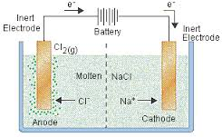

-The half-equations and redox equation for the reaction are:

Oxidation: 2Cl⁻_{(l)} Cl_{2(g)} + 2e⁻
Reduction: Na⁺_{(l)} + e⁻ Na_{(s)}
Overall: 2Na⁺_{(l)} + 2Cl⁻_{(l)} 2Na_{(s)} + Cl_{2(g)}

-While the E° values for these reactions are not completely applicable, as the concentrations of ions is greater than 1 molL⁻¹, they provide an indication of how likely the reaction is to occur

Oxidation: 2Cl⁻_{(aq)} Cl_{2(g)} + 2e⁻ E° = -1.36 V
Reduction: Na⁺_{(aq)} + e⁻ Na_{(s)} E° = -2.71 V
Overall: 2Na⁺_{(aq)} + 2Cl⁻_{(aq)} 2Na_{(s)} + Cl_{2(g)} E° = -4.07 V

-The high E° value indicates that the reaction will not occur spontaneously. This is why electrical energy needs to be provided to drive the reaction.

An electrolytic cell contains:
-battery/power source to provide e⁻ to one electrode and remove e⁻ from the other

-two unreactive electrodes (typically graphite or metal), one connected to each terminal

-the cell contents (electrolyte) (molten salt or salt solution)

-Note: a salt bridge is NOT required in an electrolytic cell

What happens in an electrolytic cell
-e⁻ travel from the – terminal of the power supply to the negative electrode (cathode)

-The electrons drive the process of reduction at cathode (Na⁺ + e⁻ → Na)

-positive ions are attracted to cathode and – ions to the anode, resulting in net flow of – charge towards anode

-oxidation takes place at positive electrode (anode) (2Cl⁻ → Cl₂ + 2e⁻)

-electrons given up in oxidation travel back to positive terminal of power source, completing the circuit

-charge flows throughout the circuit, as electrons in the wires and as ions in the electrolyte.

Predicting electrolysis products for molten ionic substances
-Whenever a molten ionic substance undergoes electrolysis (at a sufficiently high voltage):

-Anions (- ions) are oxidised at the anode as they are the only species that can readily lose electrons

-Cations (+ ions) are reduced at the cathode as they are the only substance present that can readily gain electrons

Electrolysis of Solutions

-When ionic liquids (eg molten NaCl or Al₂O₃) undergo electrolysis, only two species are present in the electrolyte (eg Na⁺ and Cl⁻ ions)

-As such, the cation will always be reduced, and the anion will always be oxidised

-When aqueous solutions undergo electrolysis, water is present in the electrolyte in addition to the dissolved ions (while technically H⁺ and OH_ are present, their concentration is very small in neutral solution.

-This means that water is also able to be oxidised or reduced, according to the following half reactions:

2H₂O_{(l)} + 2e⁻ H_{2(g)} + 2OH⁻_{(aq)} E° = -0.83V E_{(neutral)} = -0.41 V
2H₂O_{(l)} O_{2(g)} + 4H⁺_{(aq)} + 4e⁻ E° = -1.23 V E_{(neutral)} = -0.82 V

-When an aqueous solution undergoes electrolysis, the strongest oxidant present will be reduced and the strongest reductant present will be oxidised (can be estimated using E° values, although this is not always accurate as electrolysis is rarely performed under standard conditions)

Example: Write half equations and a balanced redox equation for the reaction the occurs when sodium chloride solution undergoes electrolysis under standard conditions.

Species present: H₂O_{(l)}, Na⁺_{(aq)}, Cl⁻_{(aq)}
Possible oxidation reactions: 2Cl⁻_{(aq)} Cl_{2(g)} + 2e⁻ E° = -1.36V
2H₂O_{(l)} O_{2(g)} + 4H⁺_{(aq)} + 4e⁻ E° = -1.23 V

Water is the strongest reductant present (its oxidation half-reaction has the highest E°), so it will be oxidised

Possible reduction reactions: Na⁺_{(aq)} + e⁻ Na_{(s)} E° = -2.71V
2H₂O_{(l)} + 2e⁻ H_{2(g)} + 2OH⁻_{(aq)} E° = -0.83V
Water is the strongest oxidant present (its reduction half-reaction has the highest E°), so it will be reduced

Overall equation: 6H₂O_{(l)} + O_{2(g)} + 4H⁺_{(aq)} +2H_{2(g)} + 4OH⁻_{(aq)}
Which simplifies to: 2H₂O_{(l)} + O_{2(g)} + 2H_{2(g)}

